PSG COLLEGE OF TECHNOLOGY, COIMBATORE – 641 004
Department of Applied Mathematics and Computational Sciences
M Sc SOFTWARE SYSTEMS – Semester IV
20XW48 – Web Designing Lab
PROBLEM SHEET 1 – HTML Basic Tags

Start Date: 23.12.2021 Complete Date: 30.12.2021

- Write HTML code to develop a web page having the background in red and title as “My First Page”.
<!DOCTYPE html>
<html>
<head>
<title>My First Webpage</title>
</head>
<body bgcolor = "red">
</body>
</html>
- Print the numbers 1 - 10, each number being a different color.
<!DOCTYPE html>
<html>
<head>
<title>2</title>
</head>

<body>
<font color="red">1</font>
<font color="orange">2</font>
<font color="yellow">3</font>
<font color="green">4</font>
<font color="blue">5</font>
<font color="indigo">6</font>
<font color="violet">7</font>
<font color="gray">8</font>
<font color="cyan">9</font>
<font color="black">10</font>

</body>
</html>
- Create a HTML document giving details of your name, age, mobile no, address & enrollment no. aligned in proper order?
<!DOCTYPE html>
<html>
<head>
<title>3</title>
</head>

<body>
<p align="left">
<font>Name : jass</font><br>
<font>Address: XXXXXXXXXXXXX<font><br>
<font>Mobile : **********<font><br>
</p>

<p align="center">
<font>Name : jass</font><br>
<font>Address: XXXXXXXXXXXXX<font><br>
<font>Mobile : **********<font><br>
</center>

<p align="right">
<font>Name : jass</font><br>
<font>Address: XXXXXXXXXXXXX<font><br>
<font>Mobile : **********<font><br>
</p

</body>
</html>

- Write a HTML code to print your name with different heading style.
<!DOCTYPE html>
<html>
<head>
<title>4</title>
</head>

<body>
<h1>Heading 1</h1>
<h2>Heading 2</h2>
<h3>Heading 3</h3>
<h4>Heading 4</h4>
<h5>Heading 5</h5>
<h6>Heading 6</h6>

</body>
</html>
- Print a paragraph that is a description of a book, include the title of the book as well as its author. Names and titles should be underlined, adjectives should be italicized and bolded.
- Print a paragraph with 4 - 5 sentences. Each sentence should be in a different font.
- Design a page having background color, given text color red and use all the attributes of font tag.
- Print the squares of the numbers 1 - 20. Each number should be on a separate line, next to it the number 2 superscripted, an equal sign and the result. (Example: 10² = 100)
- Prints 10 names with a line break between each name. The list should be alphabetized, and to do this place a subscripted number next to each name based on where it will go in the alphabetized list. (Example: Alan₁). Print first, the unalphabetized list with a subscript number next to each name, then the alphabetized list. Both lists should have an <h1> level heading.
- Print two paragraphs that are both indented using the &nbsp; command.
- Print two lists with any information you want. One list should be an ordered list, the other list should be an unordered list.
- Create a HTML document containing three ordered lists: ice cream, soft serve and frozen yogurt. Each ordered list should contain a nested, unordered list of your favorite flavors. Provide a minimum of three flavors in each unordered list.
- Prints an h1 level heading followed by a horizontal line whose width is 100%. Below the horizontal line print a paragraph relating to the text in the heading.
- Print some preformatted text of your choosing. (hint: use the <pre> tag)
- Print a long quote and a short quote. Cite the author of each quote.
- Print some deleted and inserted text of your choosing.
- Print a definition list with 5 items.
- Print two addresses in the same format used on the front of envelopes (senders address in top left corner, receivers address in the center).
- Print ten acronyms and abbreviations of your choosing, each separated by two lines. Specify the data that the abbreviations and acronyms represent.
- Write a HTML code to create a web page of blue color and display links in red color.
- Create some links to various search engines (google, yahoo, altavista, lycos, etc).
- Create links to five different pages on five different websites that should all open in a new window.
- Create a page with a link at the top of it that when clicked will jump all the way to the bottom of the page. At the bottom of the page there should be a link to jump back to the top of the page.
- Design a web page to display five different images. Skip two lines between each image. Each image should have a title. Also, display each image that has a border of size 2, a width of 200, and a height of 200.
- Design a web page with two images, when the first image clicked will link to a search engine of your choice (should be opened in a new window) and when the second image clicked will link to itself and will display the image in the browser by itself.
- Design a web page as shown below using text formatting elements and lists:
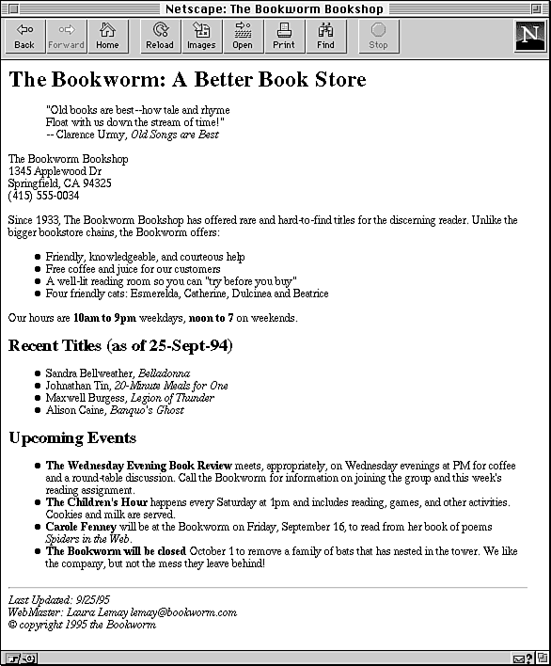
- Design a web page as shown below using text formatting elements:
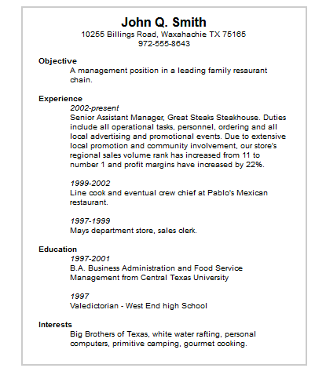
- Design the below table using HTML with background image and also with real time data (atleast five records).
Train No. | Name of the Train | Place | Destination | Time |  | Fare
 |  |  |  | Arrival | Departure | Fare
….
….

- Write a HTML code to design a table filled with images in each cell.
1 | 2 | 3 | 4
5 | Image |  | 6
7 |  |  | 8
9 | 10 | 11 | 12

- Design the below table shows the seminar schedule
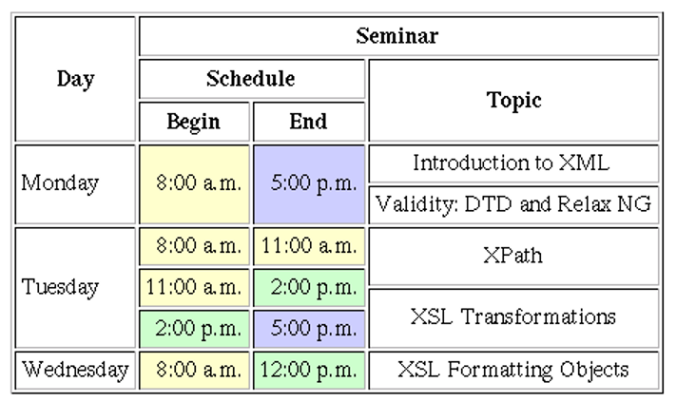
- Design a home with the contents shown below using Nested tables
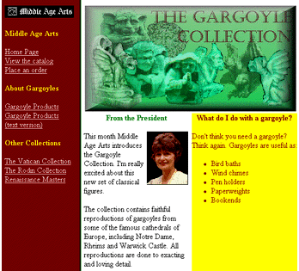

Web Resources:
- https://www.quackit.com/html/tutorial/introduction.cfm
- https://www.w3schools.com/html/
- https://www.tutorialspoint.com/html/
- http://htmldog.com/guides/html/

